 | Rajarata University of Sri Lanka  Department of Computing
 | COM 2303 – Web Design
Laboratory 06 – Introduction to Bootstrap
Time: 180 Minutes

Intended Learning Outcomes (ILOs)
By the end of this practical, students should be able to:
- Integrate the Bootstrap framework into a web project using a Content Delivery Network (CDN).
- Utilize key Bootstrap utility classes (e.g., spacing, colors, typography) to quickly style elements.
- Implement major Bootstrap components like Navigation Bars and Grid Columns.

Pre-Practical Preparation
Reading/Resources:
- Review the basics of Bootstrap: Official documentation https://getbootstrap.com/docs/5.3/getting-started/introduction/

Practical Objective
The goal of this practical is to introduce students to the efficient use of front-end frameworks like Bootstrap to accelerate development. Students will learn how to apply Bootstrap's pre-built components and utility classes.

Practical Activity

Part 1: Introduction to Bootstrap
Bootstrap is a popular front-end framework used for developing responsive and mobile-first websites. It includes a collection of HTML, CSS, and JavaScript tools that help developers create consistent and visually appealing web pages.
Bootstrap includes predefined CSS classes for easy layout options!

Task 1: Integrating Bootstrap via CDN
- Objective: Successfully link the Bootstrap framework into a new HTML document using the Content Delivery Network (CDN) method to enable immediate access to Bootstrap's styling and components.
- Instructions:
- Create a new HTML file named dashboard_bootsrap.html.
- Bootstrap Integration: Implement the basic HTML5 document structure and place the necessary links and script tags in their correct locations.
- CSS Link: Place the Bootstrap CSS link in the <head> section.
- JS Script: Place the Bootstrap JavaScript bundle (<script>) before the closing </body> tag.
- Add the following viewport meta tag within your <head> section.
<meta name="viewport" content="width=device-width, initial-scale=1">
Why the Viewport Tag is Essential: Bootstrap is a mobile-first framework. This meta tag ensures that the page width is set to the device's actual screen width, allowing Bootstrap's responsive grid system to function correctly on all phones and tablets.
- Open the page in your browser. The default font family and basic element styling should have changed, confirming successful integration (Fig. 1).

Fig. 1. Appearance of the Bootstrap applied sample webpage
<!DOCTYPE html>
<html lang="en">
<head>
<meta charset="utf-8">
<meta name="viewport" content="width=device-width, initial-scale=1">
<title>Bootstrap demo</title>
<link href="https://cdn.jsdelivr.net/npm/bootstrap@5.3.8/dist/css/bootstrap.min.css" rel="stylesheet" integrity="sha384-sRIl4kxILFvY47J16cr9ZwB07vP4J8+LH7qKQnuqkuIAvNWLzeN8tE5YBujZqJLB" crossorigin="anonymous">
</head>
<body>
<h1>Hello, world!</h1>
<script src="https://cdn.jsdelivr.net/npm/bootstrap@5.3.8/dist/js/bootstrap.bundle.min.js" integrity="sha384-FKyoEForCGlyvwx9Hj09JcYn3nv7wiPVlz7YYwJrWVcXK/BmnVDxM+D2scQbITxI" crossorigin="anonymous"></script>
</body>
</html>
Task 2: Utility Styling and Base Container
- Objective: Use basic Bootstrap utility classes to control global styling and set up the main container.
- Instructions:
- Remove the <h1> tag from task 1.
- Create a Bootstrap container <div class="container-fluid"> to allow full-width responsiveness.

Part 2: Bootstrap Components and Grid Layout
Task 3: Introducing Bootstrap Components with a Responsive Navigation Bar
- Objective: Implement a pre-built Bootstrap navigation bar component to serve as the dashboard header.
- Instructions:
- Find the code for a basic Bootstrap Navbar component.
- Add the Navbar component code to the of the body (do not put it inside the <div class="container-fluid">, because navbar is already contained inside a container-fluid division). Use classes like navbar-expand-lg and a background color class (.bg-dark or .bg-primary).
- Modify the component to include links for Home, Products, Orders, and About Us.
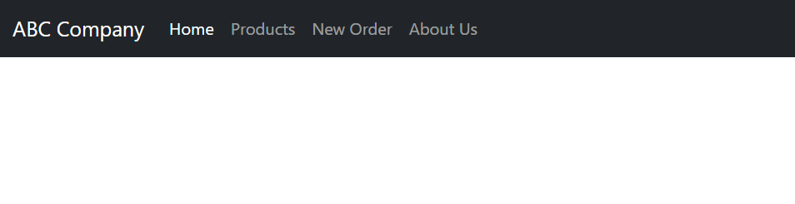
Fig. 2. Adding the navbar component from Bootstrap (Desktop view)
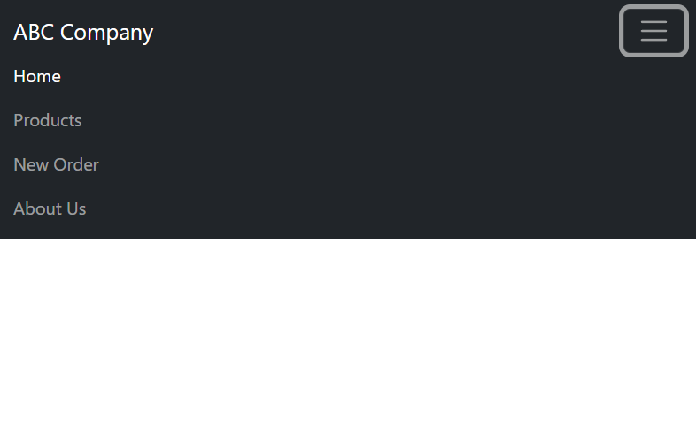
Fig. 3. Adding the navbar component from Bootstrap (Mobile view, expanded navbar)
<nav class="navbar navbar-expand-lg bg-dark border-bottom" data-bs-theme="dark">
<div class="container-fluid">
<a class="navbar-brand" href="#">ABC Company</a>
<button class="navbar-toggler" type="button" data-bs-toggle="collapse" data-bs-target="#navbarNav" aria-controls="navbarNav" aria-expanded="false" aria-label="Toggle navigation">
<span class="navbar-toggler-icon"></span>
</button>
<div class="collapse navbar-collapse" id="navbarNav">
<ul class="navbar-nav">
<li class="nav-item">
<a class="nav-link active" aria-current="page" href="#">Home</a>
</li>
<li class="nav-item">
<a class="nav-link" href="#">Products</a>
</li>
<li class="nav-item">
<a class="nav-link" href="#">New Order</a>
</li>
<li class="nav-item">
<a class="nav-link" href="#">About Us</a>
</li>
</ul>
</div>
</div>
</nav>

Task 4: Using the Bootstrap Grid
- Objective: Use the Bootstrap Grid System to recreate the Sidebar and Content layout from the previous lab.
- Instructions:
Try to replicate the structure in Figure 4 and Figure 5 by using the Bootstrap Grid System.
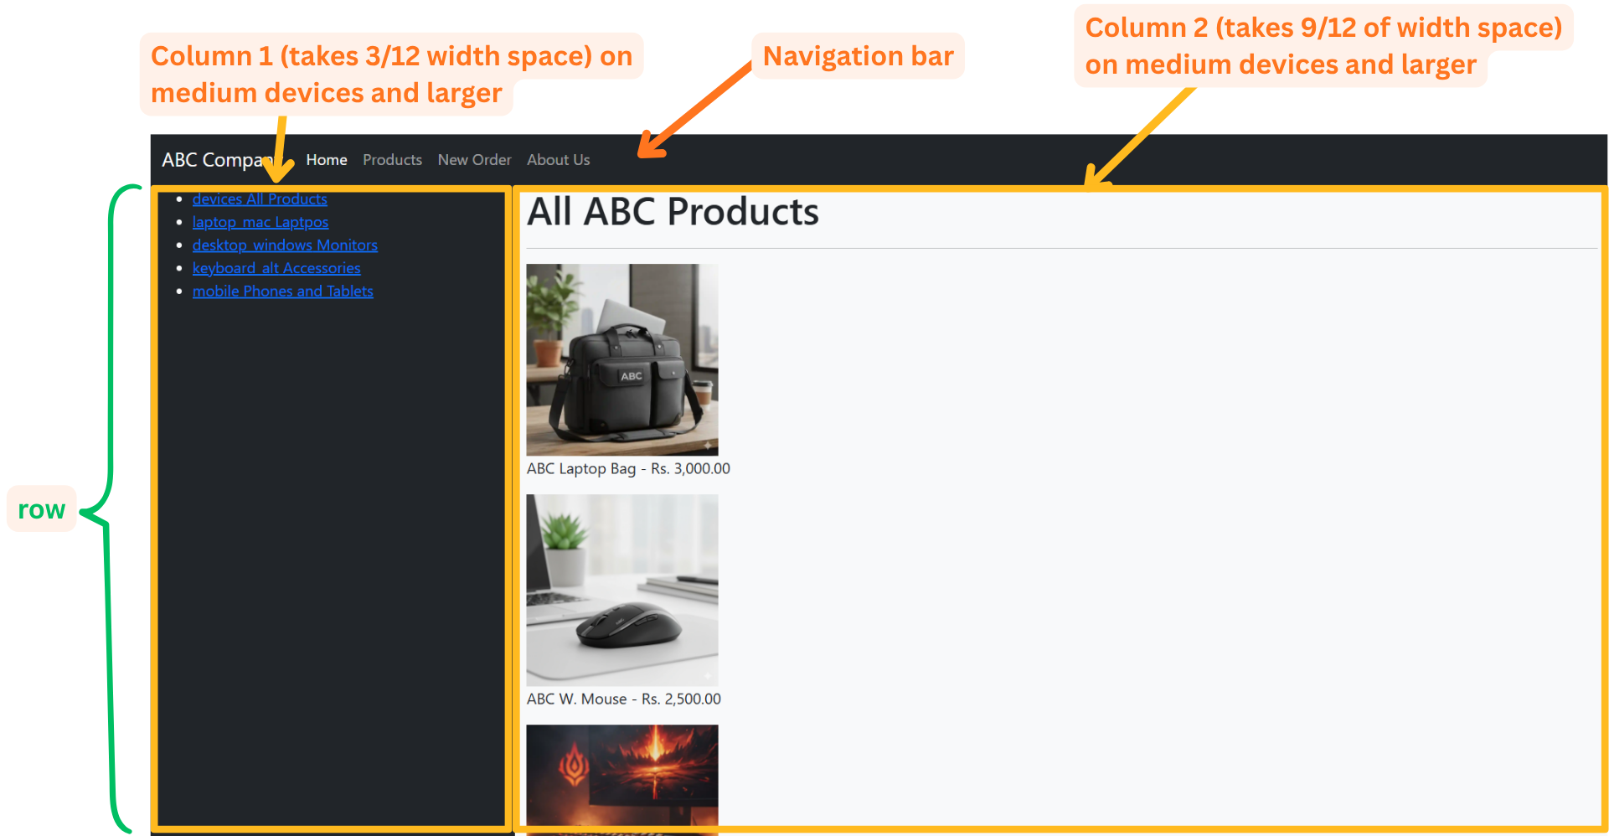
Fig. 4. A two-column structure using the Bootstrap Grid System
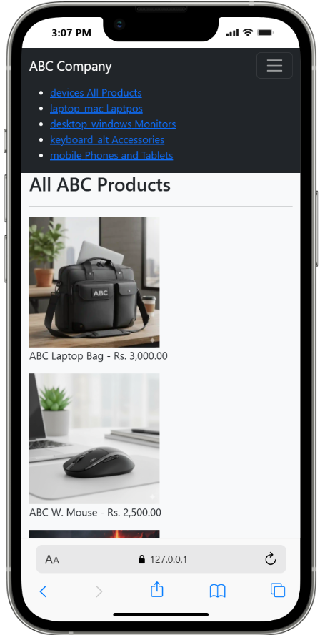
Fig. 5. In the mobile view the columns are stacking because of the responsiveness
- Inside the <div class="container-fluid"> created in task 1 create a <div class="row"> to create a Grid System.
- Create the Sidebar column: Use a class like .col-md-3 (or .col-lg-2) to define a narrow column for the sidebar on desktop screens. <div class="col-md-3">
You can change the background color by applying class like bg-dark to the division.
- Create the Content column: Use a class like .col-md-9 (or .col-lg-10) for the remaining space for the product gallery. (copy the code from previous lab sheet)
- Verify by viewing and resizing the browser window that the two columns stack vertically on small screens automatically (this is the built-in responsiveness of the Grid).
<div class="container-fluid bg-light">
<div class="row">
<div class="col-md-3 bg-dark">
<!—Sidebar codes -->
</div>
<div class="col-md-9">
<!—Content codes -->
</div>
</div>
</div>
Task 5: Using the Bootstrap Flexbox
- Objective: Style the product items using Flexbox utility classes and card components.
- Instructions:
- Wrap the products in a Flex container by adding the class .d-flex and .flex-wrap to the container holding the products.
<div class="product-gallery d-flex flex-wrap">
<figure><figcaption><img src="https://github.com/charith-ac/ict2204-com2303-practicals/blob/main/Resources/ABC_p1.webp?raw=true" height="200px" width="200px" /><figcaption>ABC Laptop Bag - Rs. 3,000.00</figcaption></figure>
<!-- rest of the products code -->
</div>
- Add a padding using class p-2 to the product gallery and justify-content-evenly to make it align evenly on the main axis (x-axis).
- Add a gap among the flex elements of gap-4
- You can also use custom CSS or modify the defaults in Bootstrap.
As an example, lets change the font size of the products gallery to 14px. Create a styles.css file and link it in the <head> tag.
<link rel="stylesheet" href="styles.css">
Let’s change the default font size provided by bootstrap to 14px.
.product-gallery {
font-size: 14px;
text-align: center;
}
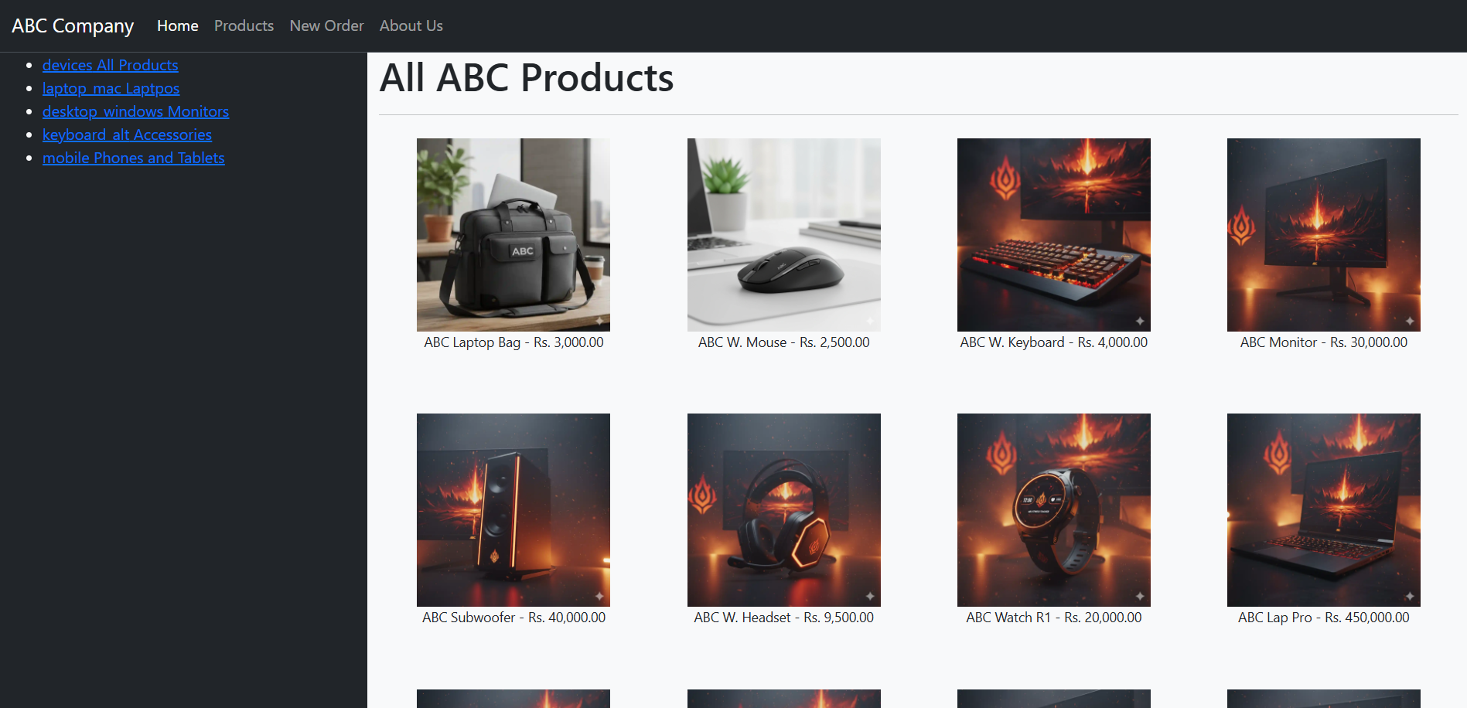
Fig. 6. Flex appearance after using the Bootstrap Flexbox on the products gallery
Task 5: Styling the Sidebar with Bootstrap Utilities
Objective: Apply a combination of Bootstrap utility classes directly to the sidebar links to remove default browser spacing and transform the raw list into a clean, full-width navigation menu.
Instructions
- Remove Default List Spacing: The list (<ul>) currently has unwanted indentation due to browser padding.
- Locate the <ul> element inside your sidebar column (.col-md-3).
- Add the utility classes list-unstyled pt-4 to the <ul> to eliminate all default bullets and add a padding of .
<ul class="list-unstyled pt-4">

</ul>
- On each <a> tag: Apply the classes text-light text-decoration-none py-2 px-3 and the Flexbox alignment utilities: d-flex gap-2 align-items-center. (Use border-bottom for visual separation).
Eg.
<a class="text-light text-decoration-none py-2 px-3 d-flex gap-2 align-items-center border-bottom" href="#">
<span class="material-symbols-outlined">devices</span> All Products
</a>
- You can use the Google material icons to get the icons.
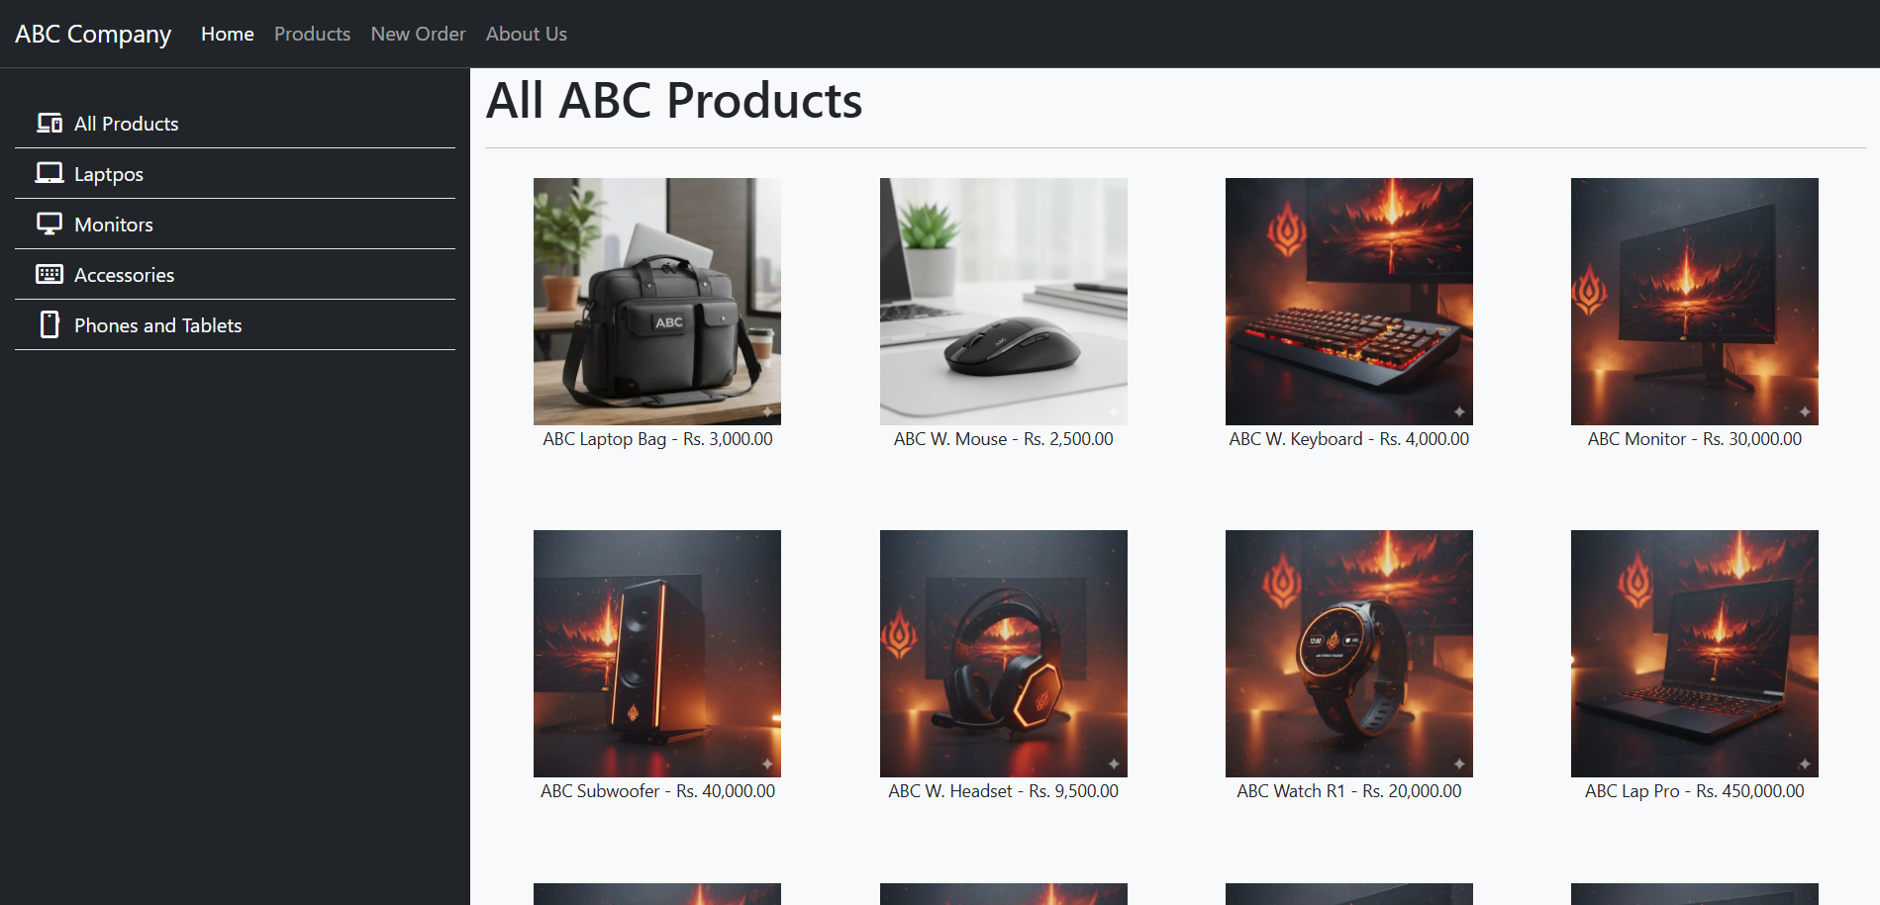
Fig. 7. Utilizing Bootstrap utilities to implement custom sidebar component

Task 6: Using Precompiled Themes (e.g., Bootswatch)
You can use customized Bootstrap themes like Bootswatch to change the look and feel of your project without custom coding.
• Example Bootswatch CDN:
<link href="
https://cdn.jsdelivr.net/npm/bootswatch@5.3.8/dist/cerulean/bootstrap.min.css
" rel="stylesheet">
Find the Theme from Bootswatch theme library and edit the Bootswatch CDN link by replacing the theme name "cerulean" with the name of the theme you selected (e.g., "sketchy").
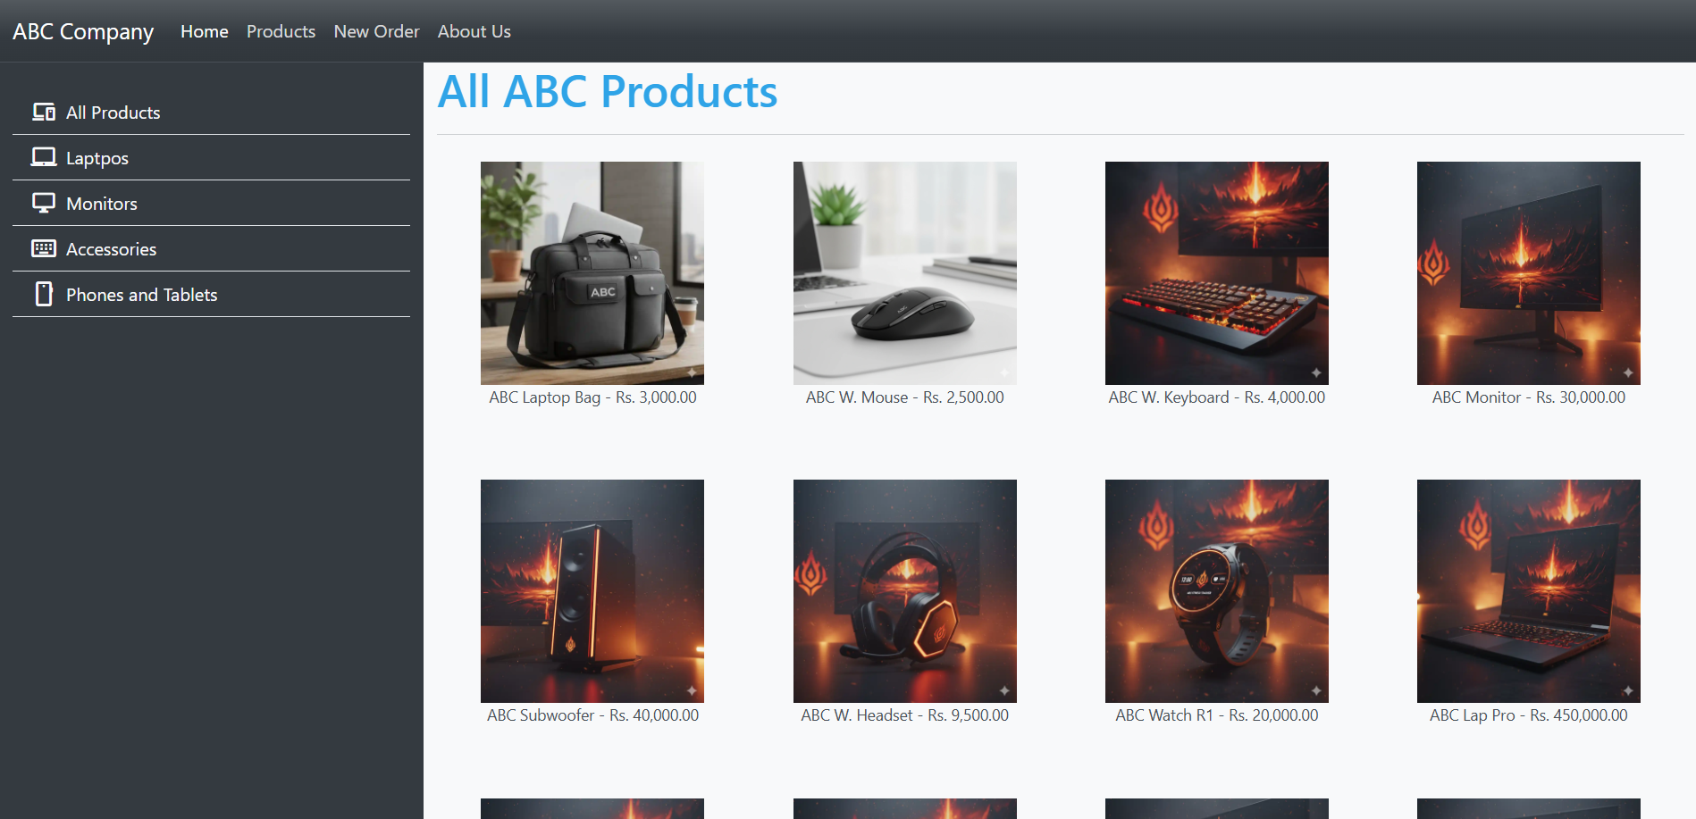
Fig. 8. Using "cerulean" theme from Bootswatch library
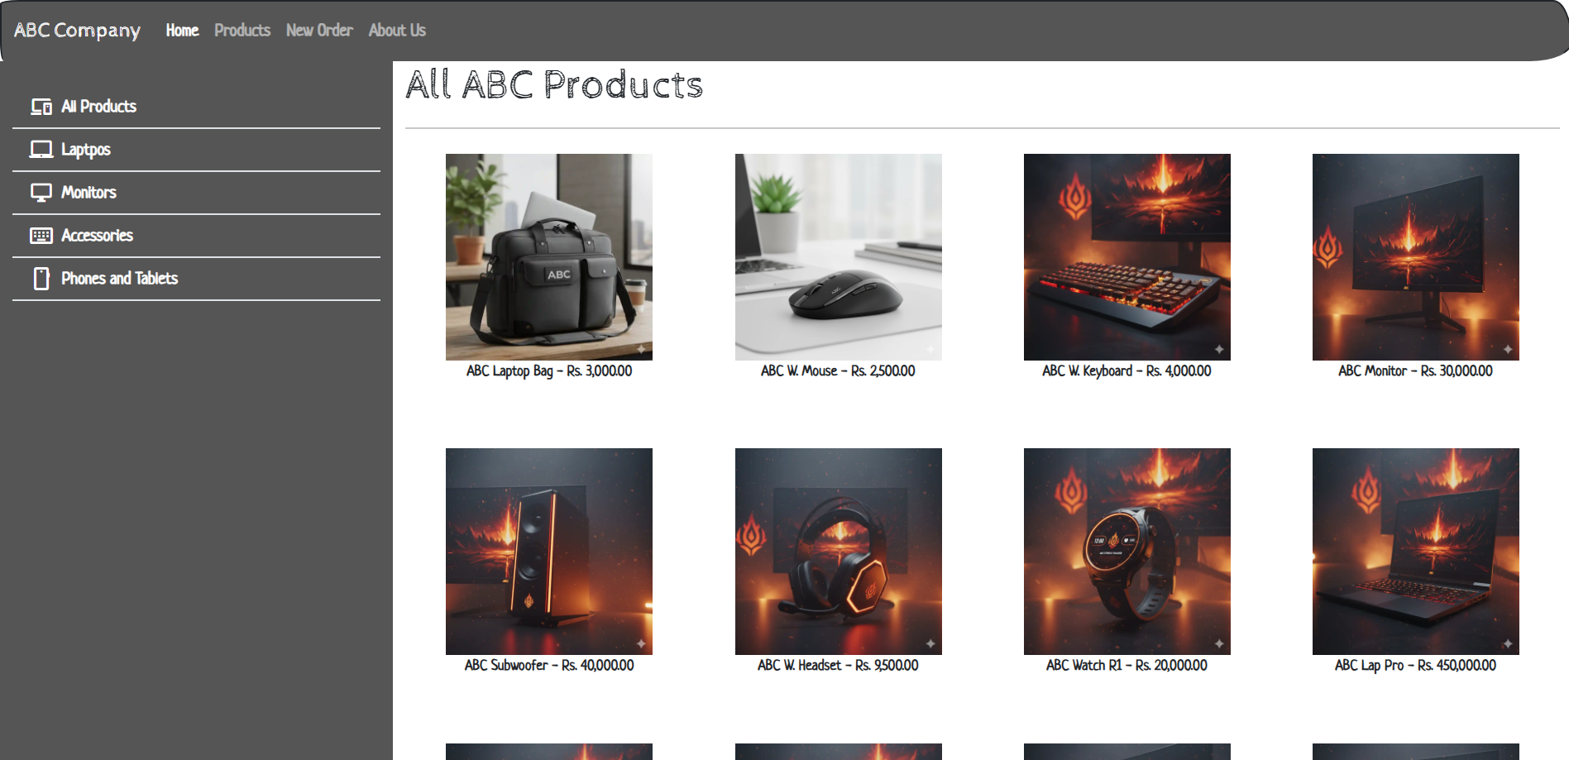
Fig. 9. Fig. 8. Using "sketchy" theme from Bootswatch library

You can find different classes in Bootstrap by referring to the official documentation. Bootstrap provides comprehensive information about its pre-defined classes for layout, components, utilities, and more.
Go to Bootstrap Docs. The navigation menu on the left side provides categorized sections such as:
- Layout (grid system, containers)
- Content (typography, images)
- Components (buttons, cards, navbars)
- Utilities (spacing, colors, borders)
Or if you’ve downloaded Bootstrap, you can still easily explore the available classes by examining the CSS files. Make sure that you use the un-minified css file. Just open and explore it in a code/text editor.

Challenge Task: Improve the Previous HTML Challenge with Bootstrap
- Open your profile_page.html from the last practical.
- Link Bootstrap to the file.
- Enhance the design:
  - Add a responsive navigation bar.
  - Use a grid layout to organize sections.
  - Style the contact form with Bootstrap classes.
If you don’t have your last practical work with you, the same sample from earlier sheet is below.

Sample Starter Code for Mythical Theme
<!DOCTYPE html>
<html lang="en">
<head>
<title>The Enchanted Grove</title>
<meta charset="UTF-8">
</head>
<body>
<div>
<header>
<h1>Welcome to the Enchanted Grove &#127794;</h1>
<h3>Journey Through Myths and Magic</h3>
</header>

<section>
<h2>Meet the Keeper of the Grove</h2>
<p>Greetings, traveler! I am [Your Mythical Name], guardian of forgotten lore.</p>
<ul>
<li>Whispering to Trees &#127794; </li>
<li>Reading Stars &#11088; </li>
<li>Igniting the Flames &#128293; </li>
</ul>
<img src="https://via.placeholder.com/150" alt="Mystical Forest Image">
</section>

<section>
<h2>Contact the Oracle</h2>
<form>
<label for="name">Your Name:</label>
<input type="text" id="name" name="name" required><br><br>

<label for="email">Your Email:</label>
<input type="email" id="email" name="email" required><br><br>

<label for="message">Your Message:</label><br>
<textarea id="message" name="message" rows="4" required></textarea><br><br>

<button type="submit">Summon Me</button>
</form>
</section>
</div>

<div>
<footer>
<p>May the stars guide you &copy; 2024 Enchanted Grove</p>
<a href="https://www.example.com">Visit the Archives</a>
</footer>
</div>
</body>
</html>

Sample Starter Code for the Professional Theme
<!DOCTYPE html>
<html lang="en">
<head>
<title>John Doe - Web Developer</title>
<meta charset="UTF-8">
</head>
<body>
<div>
<header>
<h1>John Doe</h1>
<h3>Aspiring Front-End Developer</h3>
</header>

<section>
<h2>About Me</h2>
<p>Hello! I’m John, a web development enthusiast. My goals</p>
<ul>
<li>Web Design</li>
<li>Coding</li>
<li>Creating Engaging User Experiences</li>
<li>Exploring New Technologies &#128293;</li>
</ul>
<img src="https://via.placeholder.com/150" alt="Profile Image">
</section>

<section>
<h2>Contact Me</h2>
<form action="#" method="post">
<label for="name">Your Name:</label>
<input type="text" id="name" name="name" required><br><br>
<label for="email">Your Email:</label>
<input type="email" id="email" name="email" required><br><br>
<label for="message">Your Message:</label><br>
<textarea id="message" name="message" rows="4" required></textarea><br><br>
<button type="submit">Send Message</button>
</form>
</section>
</div>

<div>
<footer>
<p>&copy; 2024 John Doe - All Rights Reserved</p>
<a href="https://www.linkedin.com">Connect on LinkedIn</a>
</footer>
</div>
</body>
</html>

Supplementary Information for Frameworks and Assets
- Understanding the Content Delivery Network (CDN)
A CDN is a network of globally distributed servers. You link directly to the files hosted on a powerful, geographically optimized network.
- Advantages: Files are delivered from the server closest to the user, and no manual downloads or updates are required.
- Disadvantages: Requires an active internet connection to load the framework.
- Modern CSS and Component Libraries
While Bootstrap is a comprehensive framework, there are also more modern component libraries built for specific JavaScript environments (like React) for more control over styling and functionality.
Library | Type | Key Feature
Tailwind CSS | Utility-First Framework | Offers low-level utility classes (flex, pt-4, shadow-lg) that you combine directly in your HTML to build completely custom designs.
Chakra UI | Component Library (React) | A collection of accessible, modular components with powerful styling props, making it excellent for building design systems with modern JavaScript.
Shadcn/ui | Component Collection (React) | Not a traditional library, but a collection of reusable components built with Tailwind CSS. Developers copy the source code directly into their project, giving maximum control and ownership over the components.
Bulma | CSS-Only Framework | A lightweight, modular framework based on Flexbox, known for its clean syntax.

To learn more about spacing used in Bootstrap refer https://getbootstrap.com/docs/5.3/utilities/spacing/

